**Assignment (20 marks)**

* This is a group assignment. MUST have 3 - 4 students in a group.
* One of the group members MUST be assigned as a leader to manage the work and report participation percentages of each member.
* The due date for the assignment is on 15 .06. 2023, by 11.00 AM.
* You MUST submit your assignment in **softcopy** (App + Documentation).
* For this assignment you MUST develop a Java Application
* Using different programming languages will result in ZERO mark.
* Late Submission: 5 marks will be deducted per day.
* Absent for presentation: result in ZERO mark for the whole project.

**Implement ONE application with the following functions**

**Part (1)**

1. Convert FA into Regular grammar (FA can be entered as a formal definition with transition table)
2. Testing strings (up to 5 strings at once) a statement to inform user whether each string is accepted or rejected.

**Part (2)** generate CYK chart (Table) for any given grammar in Chomsky normal form (CNF)

**Input:** String to be parsed

**Output**: The program should show the following output

* 1. A human readable display of the CYK chart (Table)
  2. A statement to inform user whether the string can/cannot be generated by the grammar

For example see ; https://www.xarg.org/tools/cyk-algorithm/

**Implement a Java application with the following functions**

Example (Note: you can modify the design to look better and easier to use):

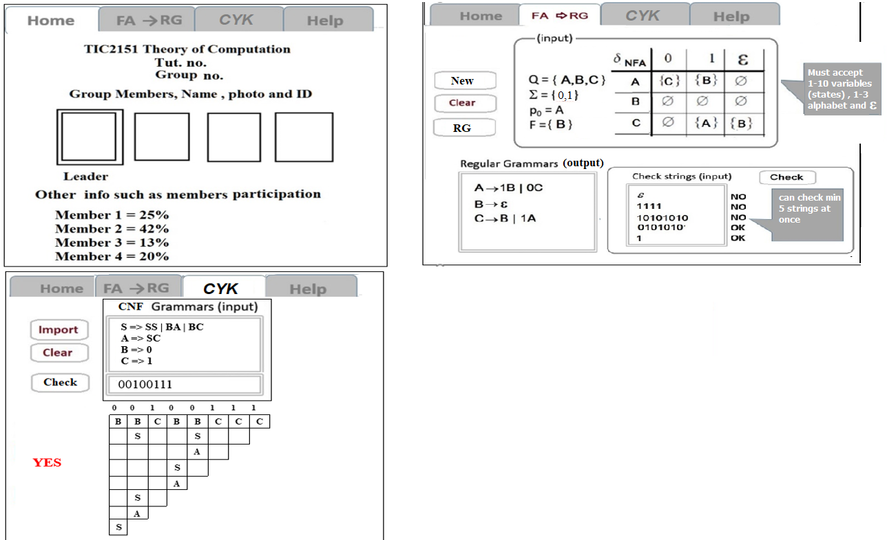

**Your submitted project must include a .exe file to start with, main screen must not be used to run other programs or take the user to another screen or page, everything must be displayed within the main screen.**

**Marks Distribution**

**Design 10 %**

**Functions: 60 %**

**Documentation + Presentation: 30 %**

**Documents must include:**

1. Cover page
2. Table of Contents
3. Members , their participation percentages and tasks
4. Introduction
5. Design Flowcharts ,
6. Algorithms
7. limitations
8. Important codes (no more than 3 pages)
9. 4 screenshots
10. Manual with examples



**TIC 2151**

**Theory of Computation**

Group Assignment

group no. (……)

The group no. (will be given by the lecturer)

Group Members

|  |  |  |
| --- | --- | --- |
| Name | ID | Participation out of 100 |
| Abc (leader) | 123451111 | 30 |
| aaaa | 123461111 | 40 |
| bbb | 123471111 | 25 |
| cccc | 123481111 | 5 |

Date of Submission: xx june 2023